# CSS Notes

<!DOCTYPE html>

<html lang="en">

<head>

    <meta charset="UTF-8">

    <meta name="viewport" content="width=device-width, initial-scale=1.0">

    <title>Box Model</title>

    <style>

        *{

            padding: 0px;

            margin: 0px;

        }   /*Reset css margin and padding*/

        .BackGround{

            background-color: aqua;

            width: 500px;

            height: 300px;

        }

        .box1{

            width: 250px;

            height: 75px;

            box-sizing: border-box; /* This will include padding and

            border in the width and height of the box */

            padding: 5px;   /*  it create space inside the div from left right top and bottum*/

            border: 5px solid black;    /*  it create border around the div*/

            margin: 5px;   /*  it create space outside the div from left right top and bottum*/

        }

        .box2{

            width: 300px;

            height: 150px;

            margin: 10px 0px 0px 10px;    /*  it create space outside the div from top right bottum and left*/

            padding: 10px 0px 0px 10px;   /*  it create space inside the div from left right top and bottum*/

        }

        .boxes{

            width: 100px;

            height: 50px;

            border: 2px solid black;    /*  it create border around the div*/

        }

/* Separate boxes using color */

        .box{

            background-color: red;

            color: yellow;

        }

    </style>

</head>

<body>

    <div class="BackGround">

        <div class="box box1">I am Box 1</div>

        <br><br>

        <div class="box box2">

            <div class="boxes">I am boxes</div>

        </div>

    </div>

</body>

</html>

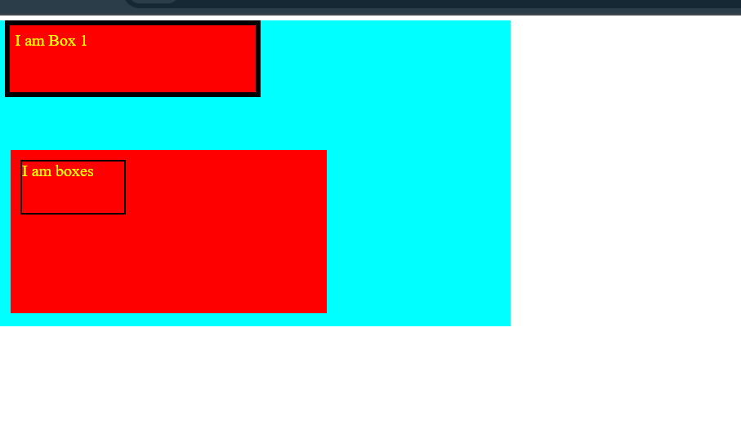

<!DOCTYPE html>

<html lang="en">

<head>

    <meta charset="UTF-8">

    <meta name="viewport" content="width=device-width, initial-scale=1.0">

    <title>Document</title>

    <style>

        *{

            /* padding: 10px 0px 0px 10px; */   /* it is not right way to use padding for main class */

            margin: 0px;

            padding: 0px;

        }

        .main1{

            width: 350px;

            height: 200px;

            border:2px solid black;

            margin: 20px;

            background-image: url("BackgroundPicture.png");

            /* background-repeat: no-repeat; */ /* it is not right way to use background-repeat for main class */

            /* background-repeat: repeat-x; */ /* it is not right way to use background-repeat for main class */

            /* background-repeat: repeat-y; */ /* it is not right way to use background-repeat for main class */

            background-repeat: repeat;

        }

        .main2{

            width: 350px;

            height: 200px;

            border:2px solid black;

            margin: 20px;

            background-image: url("BackgroundPicture.png");

            background-size: cover;   /* fits & no empty space

            /* background-size: contain; */ /* fits and image is fully visible */

            /* background-size: auto; */ /* image is not resized */

        }

        .main3{

            width: 350px;

            height: 200px;

            border:2px solid black;

            margin: 20px;

            background: red url("BackgroundPicture.png") repeat;

            /* background: red url("BackgroundPicture.png") repeat fixed left top;*/    /* give property */

            background-position:right bottom; /* set starting position of image */;

        }

    </style>

</head>

<body>

    <div class="main1">

    </div>

    <br><br>

    <div class="main2">

    </div>

    <br><br>

    <div class="main3">

    </div>

</body>

</html>

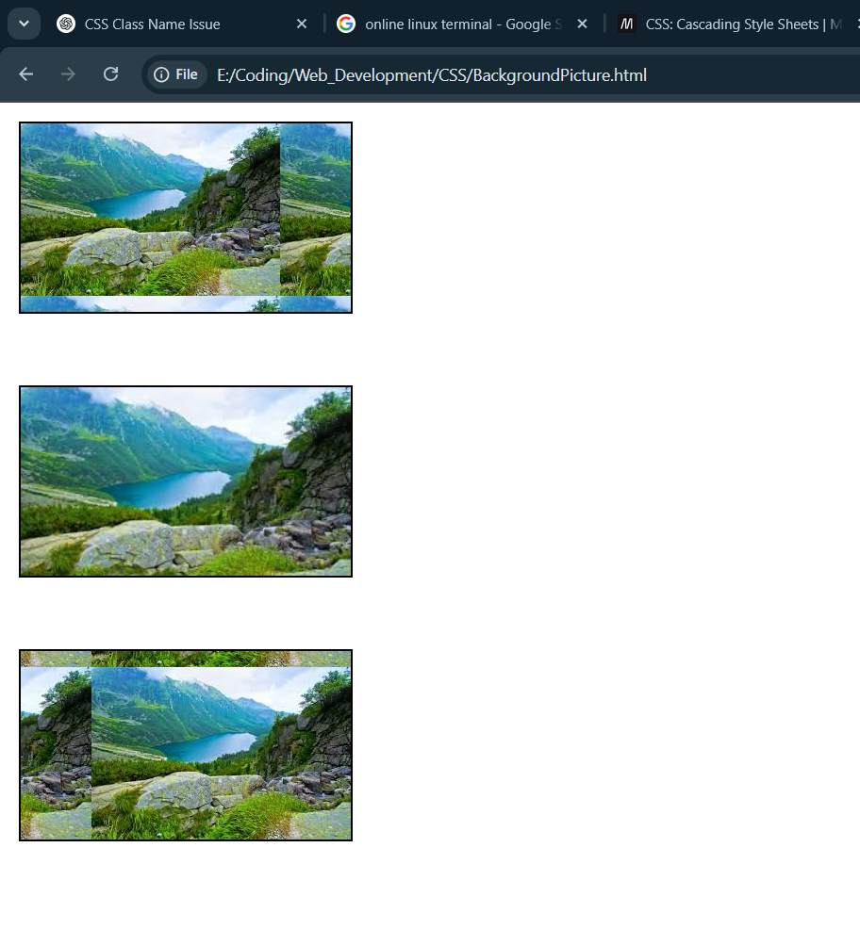

<!DOCTYPE html>

<html lang="en">

<head>

    <meta charset="UTF-8">

    <meta name="viewport" content="width=device-width, initial-scale=1.0">

    <title>Dispaly Property</title>

    <style>

        *{

            padding: 0;

            margin: 0;

        }

        .box1{

            border: 2px solid black;

            display: inline; /* it is used to make div as inline element */

            padding: 20px;  /* when use inline property then padding and margin will not work from top */

            margin: 10px;

        }

        .box2{

            border: 2px solid black;

            display: inline-block;  /* when inline-block is used then padding and margin will work from all sides*/

            padding: 20px;

            margin: 10px;

        }

        span{

            border:2px solid black;

        }

        .box3{

            border: 2px solid black;

            display: block; /* it is used to make div as block element */

            padding: 20px;  /* when use block property then padding and margin will work from all sides*/

            margin: 10px;

        }

        .e{

            display: none;  /* it is used to hide the element and there are no space*/

        }

        .c{

            visibility: hidden; /* it is used to hide the element but there are space*/

        }

    </style>

</head>

<body>

    <div class="box1">I am box a</div>

    <div class="box1">I am box b</div>

    <br><br>

    <!-- we use division tag as inline element by using display property -->

    <div class="box2 c">I am box c</div>

    <div class="box2 d">I am box d</div>

    <br><br>

    <!-- span are inline element -->

    <span>I am span 1</span>

    <span>I am span 2</span>

    <br><br>

    <div class="box3 e">I am box e</div>

    <div class="box3">I am box d</div>

</body>

</html>

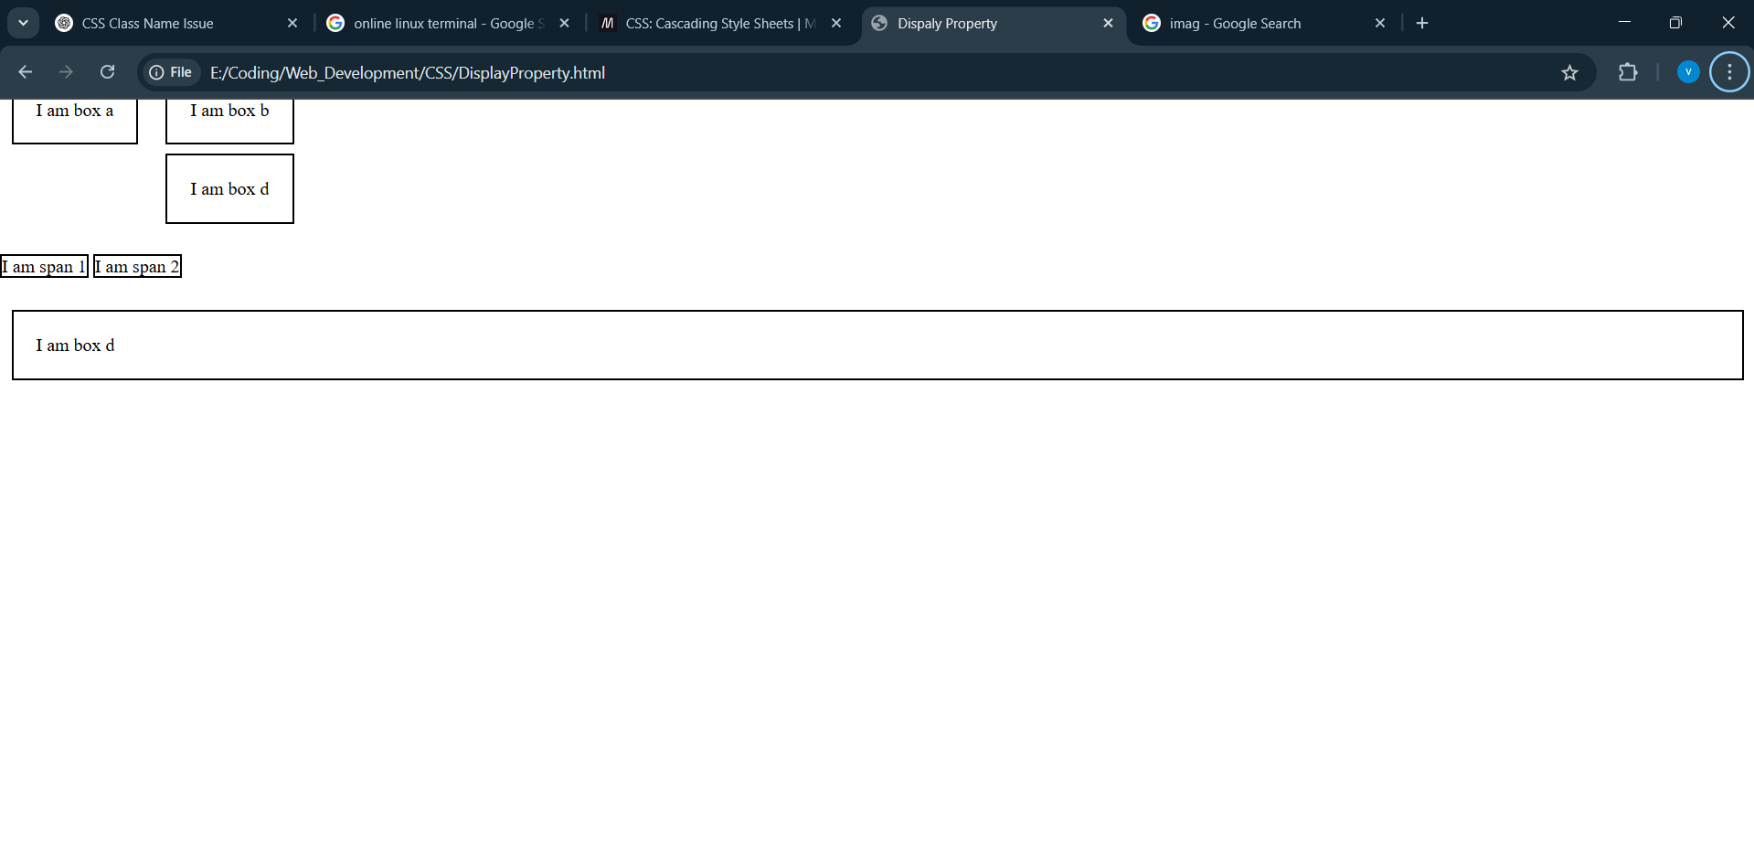

<!DOCTYPE html>

<html lang="en">

<head>

    <meta charset="UTF-8">

    <meta name="viewport" content="width=device-width, initial-scale=1.0">

    <title>Document</title>

    <style>

        *{

            padding: 0px;

            margin: 0px;

        }

        .Mytext{

        border: 10px solid blue;

        display: inline-block;

        height: 300px;

        width: 600px;

        text-align: center;  /* is used to center the text inside the div */

        /* text-align: end; */  /* is used to right align the text inside the div */

        /* text-align: start; */  /* is used to left align the text inside the div */

        text-decoration: underline;  /* is used to underline the text inside the div */

        /* text-decoration: overline;  is used to overline the text inside the div */

        /* text-decoration: line-through;  is used to line-through the text inside the div */

        text-transform: uppercase;  /* is used to convert the text inside the div to uppercase */

        line-height: 1.2;  /* is used to set the line height of the text inside the div */

        /* font attributes */

        font-family: Arial, Helvetica, sans-serif;  /* is used to set the font family of the text inside the div */

        font-size: 20px;  /* is used to set the font size of the text inside the div */

        font-style: italic;  /* is used to set the font style of the text inside the div */

        font-weight: bold; /* is used to set the font weight of the text inside the div */

    }

    </style>

</head>

<body>

    <div class="Mytext">Lorem ipsum dolor sit amet consectetur

        adipisicing elit. Unde incidunt consequatur eius, velit, tempora

        accusamus voluptates ducimus nobis adipisci quasi tempore aliquam et.

        Aliquam dolorum eveniet ratione odio magnam facilis?

    </div>

</body>

</html>

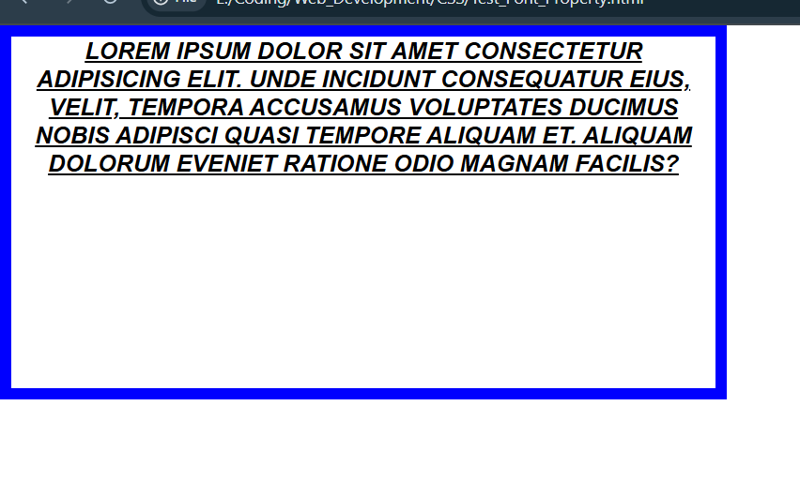

<!DOCTYPE html>

<html lang="en">

<head>

    <meta charset="UTF-8">

    <meta name="viewport" content="width=device-width, initial-scale=1.0">

    <title>Shadow and outline</title>

    <style>

        .box1{

            border: 2px solid red;  /* is used to set the border of the div border: width property color*/            box-shadow: inset -1px -3px 0px 5px yellow; /* is used to set the shadow of the div box-shadow: inset x y blur spread color*/

            /* box-shadow: outset -1px -3px 0px 5px yellow; is used to set the shadow of the div box-shadow: inset x y blur spread color */

        }

        .box2{

            outline:2px solid blue; /* is used to set the outline of the div outline: width property color*/

        }

        .mytext1{

            text-shadow: 16px 15px 11px red; /* is used to set the shadow of the text text-shadow: x y blur color*/

        }

        .mytext2{

            border : 2px solid red;

            outline: 2PX solid blue;    /* border and outline both have similer difference

            outline is set outside the border */

            outline-offset: 5px;

            height: 50px;

            width: 200px;

            display: flex;

            justify-content: center;  /* Horizontal alignment */

            align-items: center;      /* Vertical alignment */

            /* here justify-content and align-items both are worked for display flex

            if it is not add here then justify-content and align-items not working */

            border-radius: 20%;/* if we change radius of border then it is also change the radius of outline */

        }

    </style>

</head>

<body>

    <div class="box1">

        Lorem ipsum dolor, sit amet consectetur adipisicing elit. Illo, blanditiis?

    </div>

    <br>

    <div class="box2">

        Lorem ipsum dolor, sit amet consectetur adipisicing elit. Illo, blanditiis?

    </div>

    <br>

    <p class="mytext1">Lorem ipsum dolor sit amet.</p>

    <br>

    <div class="mytext2">Lorem ipsum dolor sit amet.</div>

</body>

</html>

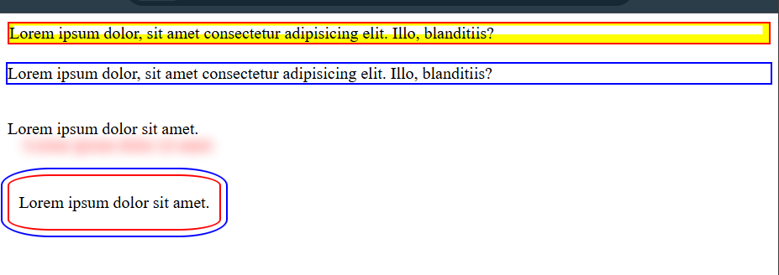

<!DOCTYPE html>

<html lang="en">

<head>

    <meta charset="UTF-8">

    <meta name="viewport" content="width=device-width, initial-scale=1.0">

    <title>CSS Lists</title>

    <style>

        nav ul li{

            /* list-style: devanagari; */ /* it is use style the list */

            list-style-type: "🔥";  /* change the type of list's bullet */

            /* background-color: yellow; */

            list-style-position: inside; /* it is used to set the position of the list's bullet inside or outside the list */

            /* list-style-position: outside; */ /* it is used to set the position of the list's bullet inside or outside the list */

            /* list-style-type: none; */ /* it is used to remove the list's bullet */

            border: 2px solid black;

            /* list-style: disc inside url("https://png.pngtree.com/png-vector/20191126/ourmid/pngtree-image-of-cute-radish-vector-or-color-illustration-png-image_2040180.jpg"); */

            /* list-style-image: url("https://png.pngtree.com/png-vector/20191126/ourmid/pngtree-image-of-cute-radish-vector-or-color-illustration-png-image_2040180.jpg"); */

        }

    </style>

</head>

<body>

    <nav>

        <ul>

            <li>Home</li>

            <li>About</li>

            <li>Contact</li>

        </ul>

    </nav>

</body>

</html>

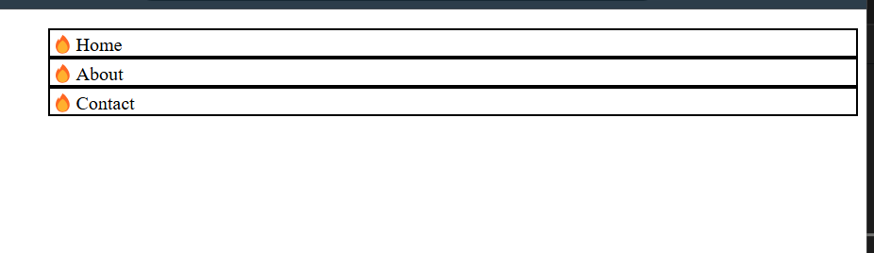

<!DOCTYPE html>

<html lang="en">

<head>

    <meta charset="UTF-8">

    <meta name="viewport" content="width=device-width, initial-scale=1.0">

    <title>Overflow</title>

    <style>

        .box {

            width: 400px;

            height: 100px;

            border: 2px solid black;

            /* overflow: auto;

            overflow-x: hidden;

            overflow-y: scroll; */

            overflow: scroll scroll;    /* overflow: x y;  is used to set the overflow of the div in x and y direction */

            overflow-wrap: break-word;  /* is used to break the word in the div when it is overflow */

            hyphens: auto;  /* is used to set the hyphens('-') in the text for next line word automatically */

            text-align: justify;    /* is used to set the text in justify format in the div */

            padding: 2px;

            /* overflow: auto hidden; auto means when there are many words then browser set

            a scrollber otherwise it looking simple and hidden use hide overflow text */

            /* white-space: nowrap;  keep all the text on one line, even if it overflows */

            /* text-overflow: ellipsis;  When there's too much text to fit in one line, it will cut

            off the overflow and show … (ellipsis) at the end. */

        }

    </style>

</head>

<body>

    <div class="box">

        I am a good boy and I love to write Lorem ipsum dolor, sit amet consectetur adipisicing elit. Dicta iure amet

        unde voluptas nihil vero, maxime esse quis quos natus rem, earum aspernatur quasi aut ea commodi nostrum

        voluptate! Sint rerum nostrum perferendis sapiente explicabo perspiciatis, ut magni? Aspernatur, provident

        dolorum unde corporis doloribus rem!

    </div>

</body>

</html>

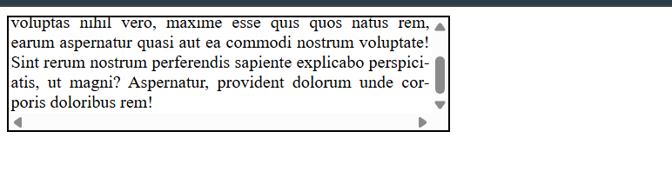

<!DOCTYPE html>

<html lang="en">

<head>

    <meta charset="UTF-8">

    <meta name="viewport" content="width=device-width, initial-scale=1.0">

    <title>CSS Position</title>

    <style>

        *{

            padding: 0;

            margin: 0;

        }

        .parent{

            margin: 10px;

            padding: 10px;

            border: 2px solid blue;

        }

        .box{

            border: 2px solid black;

            height: 25px;

            width: 100px;

        }

        .box1{

            background-color: red;

        }

        .box2{

            background-color: green;

            position: relative;

            top:10px;

            left: 20px;

        }

        .box3{

            background-color: blue;

            position: absolute;  /* set position absolute then use top

            property */

            top:0px;    /* set top position from its parent absolute */

            /* but here parent is not set position absolute */

        }

        .box4{

            background-color: yellow;

            position: fixed;    /* set position fixed, though we scroll the page

            but this box stil its position  */

        }

        .base{

            margin: 10px;

            padding: 10px;

            border: 2px solid blue;

            position: absolute;

            width: 200px;

            height: 30px;

        }

        .derived{

            border: 2px solid black;

            height: 25px;

            width: 100px;

        }

        .derived1{

            background-color: aqua;

            position: absolute;

            top: 0px;

            left: 5px;

        }

    </style>

</head>

<body>

    <div class="parent">

        <div class="box box1"></div>

    <div class="box box2"></div>

    <div class="box box3"></div>

    <div class="box box4"></div>

    </div>

    <br>

    <div class="base">

        <div class="derived derived1"></div>

    </div>

</body>

</html>

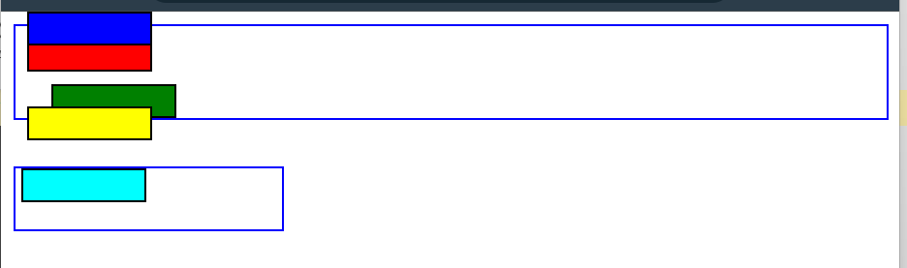

<!DOCTYPE html>

<html lang="en">

<head>

    <meta charset="UTF-8">

    <meta name="viewport" content="width=device-width, initial-scale=1.0">

    <title>Navbar using sticky.......</title>

    <style>

        * {

            padding: 0px;

            margin: 0px;

        }

        .content{

            position: sticky;

        }

        header {

            border: 2px solid black;

            height: 50px;

            background-color: brown;

            color: white;

            text-align: center;

            font-size: 25px;

        }

        .navbar{

            display: flex;

            gap: 15px;

            padding: 10px;

            position: sticky; /* sticky maens it stop scrolling when it reached 0px from top of its parents */

/* If any div given position propert then also necessery to give position propery to its parent div or other

Tag else it set from starting point */

            background-color: lightgreen;

            top: 0px;

            left: 0px;

        }

        .Text{

            padding: 5px;

            border:2px solid black;

            height: 1000px;

            width:75px;

            overflow: auto;

        }

    </style>

</head>

<body>

    <header>

        I am header

    </header>

    <div class="content">

        <div class="navbar">

            <nav>Home</nav>

            <nav>Course</nav>

            <nav>Fees</nav>

            <nav>Notes</nav>

        </div>

        <div class="Text">

            Lorem ipsum dolor, sit amet consectetur adipisicing elit. Facilis enim,

            iure neque natus modi repellendus fugiat! Odit nihil consequuntur natus

            reprehenderit deserunt magni error, quo rerum quisquam aspernatur, praesentium

            animi quam architecto repudiandae commodi nostrum sequi voluptates perspiciatis

            vero minima optio nemo quasi! At, distinctio fugit eveniet quos quibusdam

            tempore quas iusto odio molestiae eius? Sit aliquam autem dolores, labore,

            doloremque quaerat quam rerum voluptas, saepe consequuntur quibusdam magnam

            expedita exercitationem vel dolorum. Expedita dolorum fugiat corrupti nihil

            iure eius quisquam sed alias itaque odit quos, eveniet soluta excepturi ex

            placeat rem harum impedit quaerat, ut laboriosam modi dignissimos repudiandae?

        </div>

    </div>

</body>

</html>

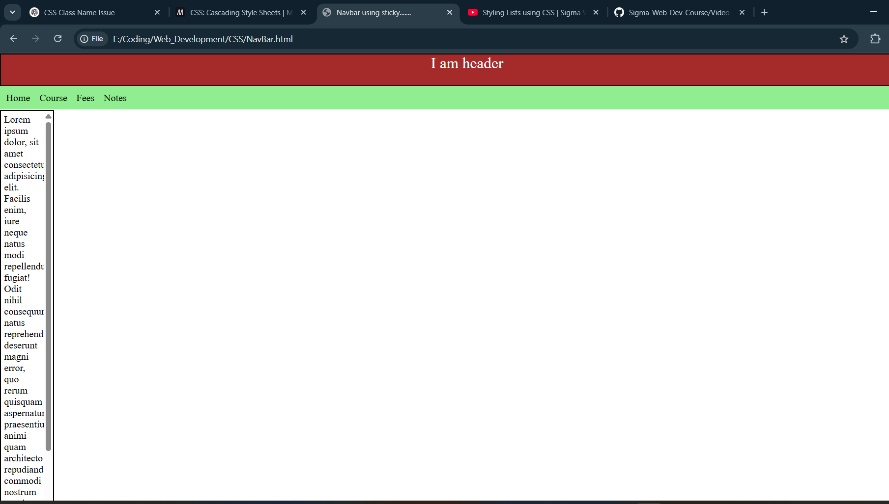

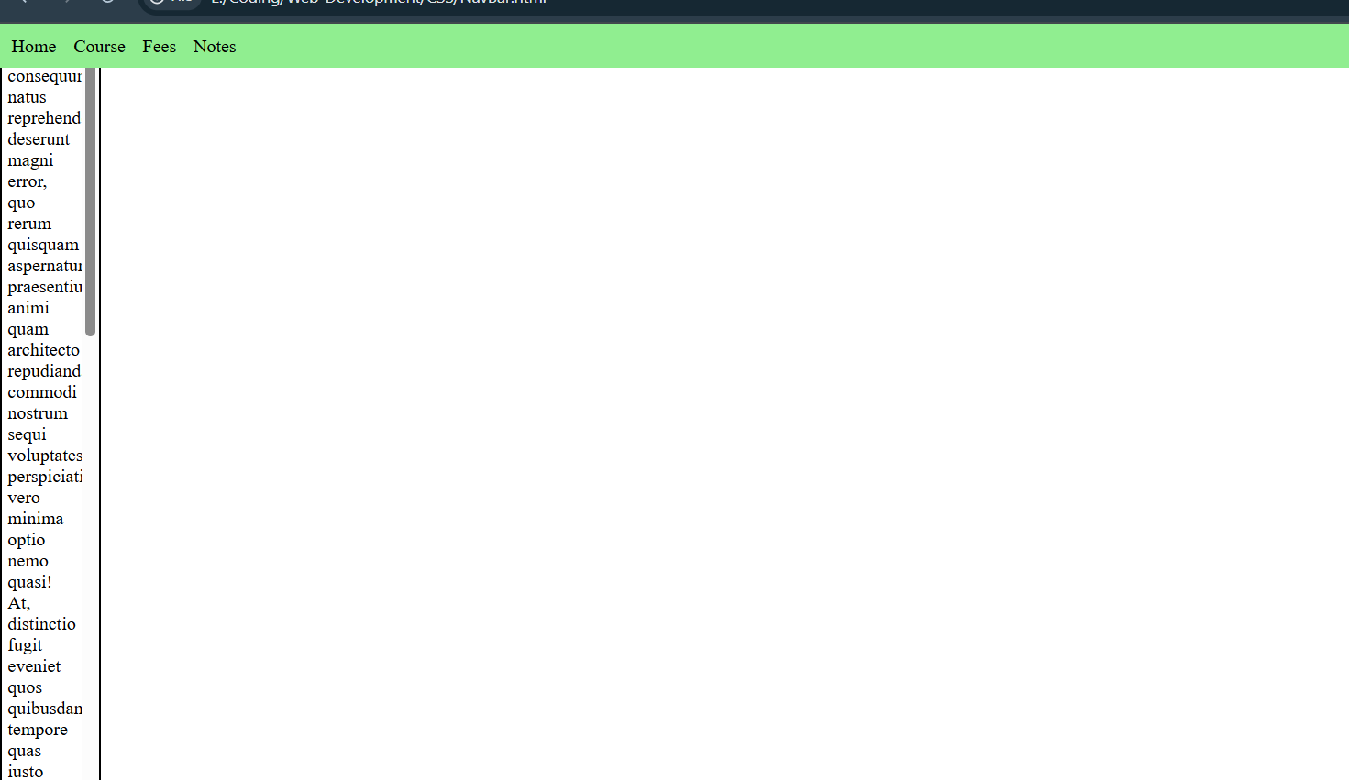

<!DOCTYPE html>

<html lang="en">

<head>

    <meta charset="UTF-8">

    <meta name="viewport" content="width=device-width, initial-scale=1.0">

    <title>Document</title>

    <style>

        :root{

            --color: red;

            --defmar: 20px;

            --boxcolor: rgb(254, 131, 0);

            --boxborder: 2px solid rgb(252, 4, 128);

        }

        *{

            margin: 0;

            padding: 0;

        }

        .main{

            margin: var(--defmar);

            border: 2px solid var(--color);

            width: 400px;

        }

        .box{

            border: var(--boxborder);

            margin: 5px;

        }

    </style>

</head>

<body>

    <div class="main">

        <div class="box box1">I am box 1</div>

        <div class="box box2">I am box 2</div>

        <div class="box box3">I am box 3</div>

    </div>

</body>

</html>

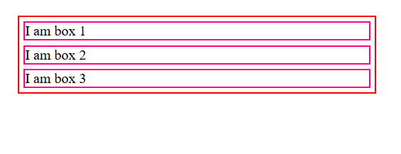

<!DOCTYPE html>

<html lang="en">

<head>

    <meta charset="UTF-8">

    <meta name="viewport" content="width=device-width, initial-scale=1.0">

    <title>Media Query</title>

    <!-- media query used set css for different devise -->

     <style>

        *{

            margin: 0;

            padding: 0;

        }

        .main{

            padding: 2px;

            border:2px solid black;

            width: 75vw;

            height: 75vh;

            margin: 20px;

            display: flex;

            gap: 3px;

            background-color: rgb(128, 240, 240);

        }

        .box{

            border: 2px solid red;

            text-align: center;

            width: 30%;

            height: 30%;

            background-color: crimson;

        }

        @media only screen and (max-width:800px){ /* this css will be applied when screen size is less than 800px */

            .main{

                flex-direction: column;

                background-color: chartreuse;

            }

            .box{

                background-color: darkred;

            }

        }

     </style>

</head>

<body>

    <div class="main">

        <div class="box">I am box 1</div>

        <div class="box">I am box 2</div>

        <div class="box">I am box 3</div>

    </div>

</body>

</html>

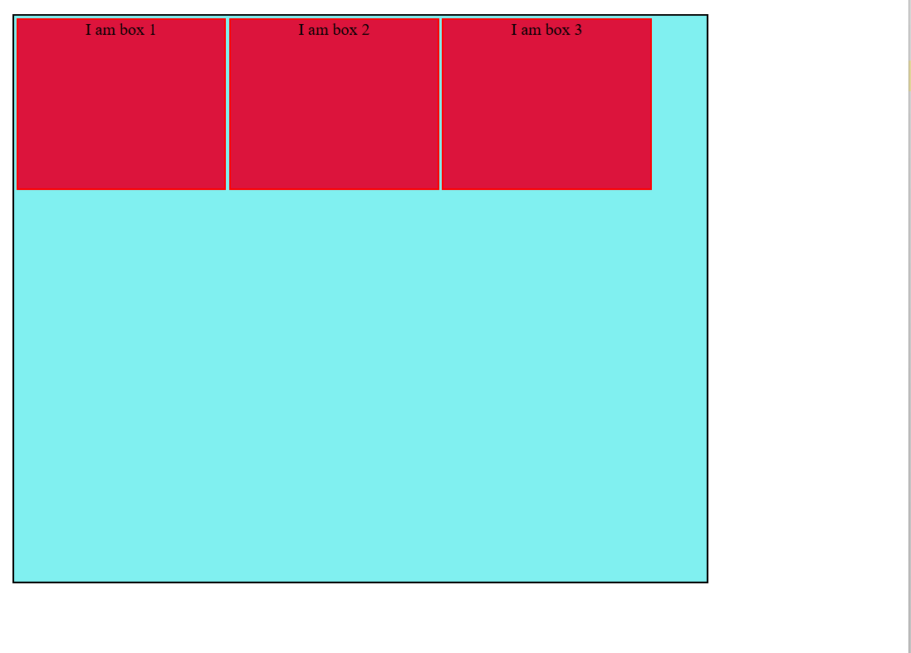

Less than equal to 800 px 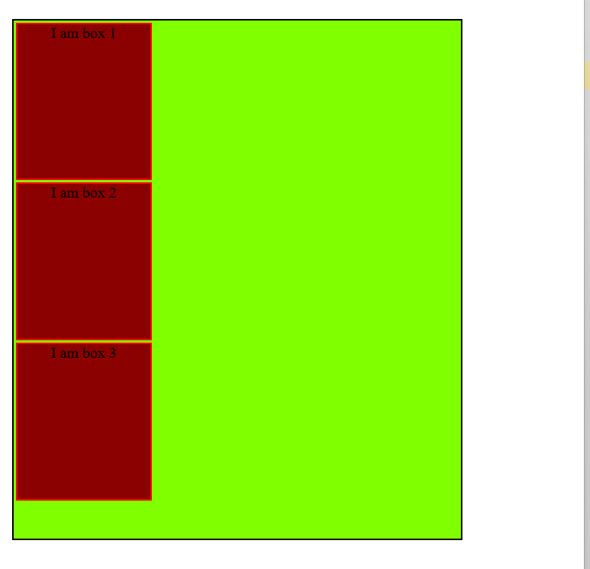

<!DOCTYPE html>

<html lang="en">

<head>

    <meta charset="UTF-8">

    <meta name="viewport" content="width=device-width, initial-scale=1.0">

    <title>Flex Box</title>

    <style>

        .container {

            border: 2px solid black;

            display: flex;

            /* margin: 5px; */

            width: 20vw;

            height: 25vh;

            flex-wrap: wrap;

            /* align items use for single row */

            /* align-items: flex-end;  show items at the end of the container */

            /* align-items: center;  show items at the center of the container */

            /* align-content use for multiple rows */

            /* align-content: flex-start;  show items at the start of the container */

            align-content: flex-end;  /* show items at the end of the container */

            /* flex-wrap is used when we have more items than the container width

            and wish to display them in multiple rows */

            /* flex-wrap: wrap-reverse;     */

            /* gap: 5px; */

            /* row-gap: 5px;

            column-gap: 5px; */

            /* gap: 5px 10px;  row-gap column-gap */

            /* flex-direction: column; show column column wise */

            /* flex-direction: column-reverse; show column column wise in reverse order */

            /* flex-flow: row wrap;    flex-direction: row; flex-wrap: wrap; */

        }

        .item {

            height: 30px;

            width: 30px;

            border: 2px solid red;

            background-color: aqua;

        }

        .item1{

            order: 2;

        }

        .item2{

            order: 2;

        }

    </style>

</head>

<body>

    <div class="container">

        <div class="item item1">1</div>

        <div class="item">2</div>   <!-- By default every class have 0 order -->

        <div class="item item2">3</div>

        <div class="item">4</div>

        <div class="item">5</div>

        <div class="item">6</div>

        <div class="item">7</div>

        <div class="item">8</div>

        <div class="item">9</div>

        <div class="item">10</div>

    </div>

</body>

</html>

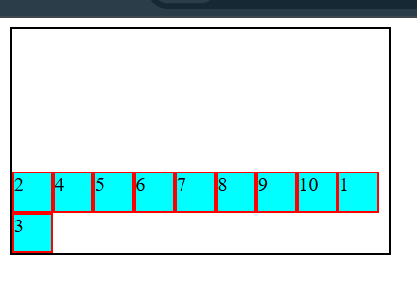

<!DOCTYPE html>

<html lang="en">

<head>

    <meta charset="UTF-8">

    <meta name="viewport" content="width=device-width, initial-scale=1.0">

    <title>Grid Property 1</title>

    <style>

        .container{

            border: 2px solid black;

            display: grid;

            /* grid-template-columns: 10vw 10vw 10vw; */

            grid-template-columns: 1fr 1fr 1fr; /* means that 1:1:1 of its parents widht */

            /* grid-template-rows: 10vh 10vh 10vh; */

            grid-template-rows: repeat(3, 10vh);    /* insted of grid-template-rows: 10vh 10vh 10vh; */

        }

        .item{

            border: 2px solid red;

            background-color:burlywood;

            width: 25%;

            height: 42%;

        }

        .item-1{

            /* grid-column-start: 3;

            grid-column-end: 4;

            grid-row-start: 3;

            grid-row-end: 4; */

            grid-row: 2/3;  /* start/end */

            grid-column:  3/4;  /* start/end */

        }

        .item-2{

            grid-area: ;

        }

    </style>

</head>

<body>

    <div class="container">

        <div class="item item-1">1</div>

        <div class="item item-2">2</div>

        <div class="item item-3">3</div>

        <div class="item item-4">4</div>

        <div class="item item-5">5</div>

        <div class="item item-6">6</div>

        <div class="item item-7">7</div>

        <div class="item item-8">8</div>

        <div class="item item-9">9</div>

    </div>

</body>

</html>

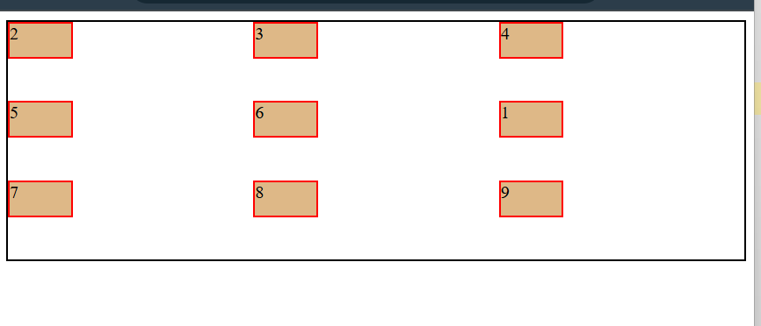

<!DOCTYPE html>

<html lang="en">

<head>

    <meta charset="UTF-8">

    <meta name="viewport" content="width=device-width, initial-scale=1.0">

    <title>CSS Grid</title>

    <style>

        .container {

            border: 2px solid black;

            display: grid;

            grid-template-areas: "nav nav nav"

                "side article article"

                "footer footer footer"

                "end end end";

        }

        .item {

            border: 2px solid red;

            height: 55px;

        }

        .item-1 {

            grid-area: nav;

            background-color: aqua;

        }

        .item-2 {

            grid-area: side;

            background-color: beige;

        }

        .item-3 {

            grid-area: article;

            background-color: azure;

        }

        .item-4 {

            grid-area: footer;

            background-color: bisque;

        }

        .item-5 {

            grid-area: end;

            background-color: blueviolet;

        }

    </style>

</head>

<body>

    <div class="container">

        <div class="item item-1">1</div>

        <div class="item item-2">2</div>

        <div class="item item-3">3</div>

        <div class="item item-4">4</div>

        <div class="item item-5">5</div>

    </div>

</body>

</html>

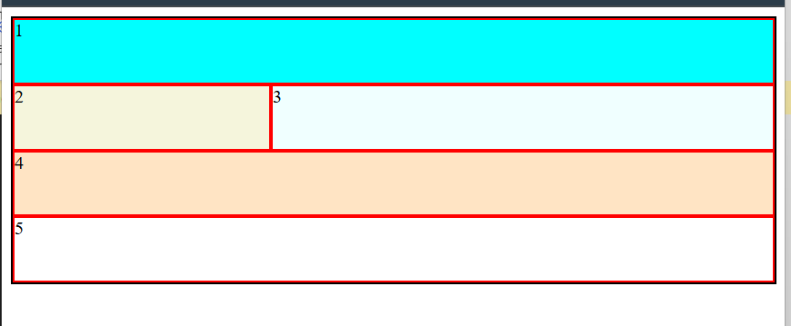

<!DOCTYPE html>

<html lang="en">

<head>

    <meta charset="UTF-8">

    <meta name="viewport" content="width=device-width, initial-scale=1.0">

    <title>Document</title>

    <style>

        .container{

            border: 2px solid black;

            height: 400px;

            width: 500px;

        }

        img{

            border: 2px solid red;

            height: 300px;

            width:400px;

            /* to fix the iamge above height and width we use object-fit */

            object-fit: cover; /* cover the ratio of the image and cut the extra part */

            /* object-fit: contain;    show the whole image */

            /* object-position: center center; center the image */

            object-position: top left; /* top left the image */

        }

    </style>

</head>

<body>

    <div class="container">

        <img src="BackgroundPicture.png" alt="nature">

    </div>

</body>

</html>

